Shuf Op - The aaBridge Button

Written by Roger Pfister http://RogerPf.com/aaBridge

Open aaBridge and select the text on the lines below

qx|5|rh||ah|Deal 5|
md|1s85hAQJ82dAKcT742,,sK62h764dQ732cAK5|
sv|N|sk|S|
mb|1H|mb|p|mb|1N|mb|p|mb|2C|mb|p|mb|4H|mb|p|mb|p|mb|p|
aa|y|
at|^^^bYou ruff the 3rd round of @s's low. Please plan the play.|
pc|sQ|

Now drag and drop those lines on to an open aaBridge window.
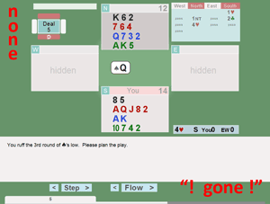

Because of the at|| command in the text, aaBridge will show this simple 'Lin file' in tutorial mode so there will be no Shuf Op button (none) .

Also because this deal has no East or West cards supplied aaBridge will NOT show you the
Enter the Deal button, marked "gone" in the image.

You can tell aaBridge that you still want to see the
Enter the Deal button even for these incomplete deals
by checking the
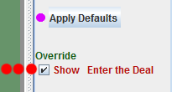
Override - Show Enter the Deal checkbox in the
column on the far right (3 red dots)

and the Enter the Deal will show (on older versions of aaBridge you may need to then click Flow > to have it appear).

Now please click Enter the Deal
<continued on next page>

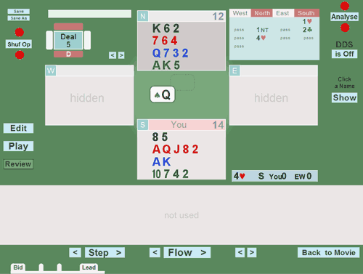
The important buttons are now
Shuf Op and Analyse

If you click Analyse you will see that the window tells you that there are not 52 cards and you need to click Shuf Op

Every time you click

Shuf Op

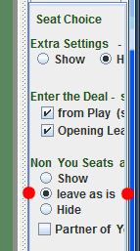
a different of Opps hands will be dealt.
If you also have the Analyser switched on then for each click of Shuf Op the Analyser will run and you will see the contracts that can be made.

To automatically show the East West cards you can check the
leave as is check box in the far right column.

THEN the normal Show / Hide button setting will be remembered between each press of Shuf Op.

Shuf Op has a main purpose of allowing the user to replay a hand against a different layout of the Opps cards hence it is normal to hide the new layout.

If you want a layout that conforms to the requirements of this problem you need to keep clicking until you see East with the Ace of spades. You can then hide the East West cards and try out your own plan (your answer to the question).

<continued on next page>
Summary – with this method you can fill in missing hands from any problem that you have entered into aaBridge.

Note - The actual cards dealt on the day are not important – the important thing is that you generate the best plan you can given the bidding and the cards you can actually see.

A note for Lin file Authors
Lin file authors can be more sophisticated when it comes to controlling which cards will or will not be shuffled. Drop this example into aaBridge

qx|5 adv|rh||ah|Deal 5_adv|
md|1s85hAQJ82dAKcT742, sQJT43,sK62h764dQ732cAK5,sA97|
kc| sQJT43 sA97|
sv|N|sk|S|
mb|1H|mb|p|mb|1N|mb|p|mb|2C|mb|p|mb|4H|mb|p|mb|p|mb|p|
at|^^^bYou ruff the 3rd round of @s's low. Please plan the play.|
pc|sQ|

Now drag and drop those lines on to an open aaBridge window and again
use Analyse and Shuf Op

What you will notice is that the E-W spade suits are now supplied in then deal and the kc

kc| sQJT43 sA97| command (Keep Cards)

tells the Shuf Op mechanism that those cards should NOT be shuffled and indeed they are not shuffled.

There are other ways to achieve this (eb - eBlocker command) and you can even use BBO compatible dealer for even more sophisticated Dealer system that comes with BBO.

See the aaBridge Document Collection and What goes on inside a lin file at the end of each aaBridge menu for more information.

<end document>

